**Subscribers Galore: Exploring World ‘s Top YouTube Channels**

**Introduction:**

**Subscribers Galore is not just any YouTube channel: it is the ultimate hub for content creators and subscribers alike. With a massive following and an unparalleled reputation, subscribers Galore has established itself as the world’s top YouTube channel**.

**Problem Definition:**

**Exploring the challenges faced by the world’s Top YouTube channel.**

**Empathy Map:**

**An empathy Map is tool used to understand and empathize with a particular user or customer. It helps teams gain insights into the thoughts, feelings, needs, and motivations of the individuals they are designing products or services for. The empathy map is divided into four quadrants.**

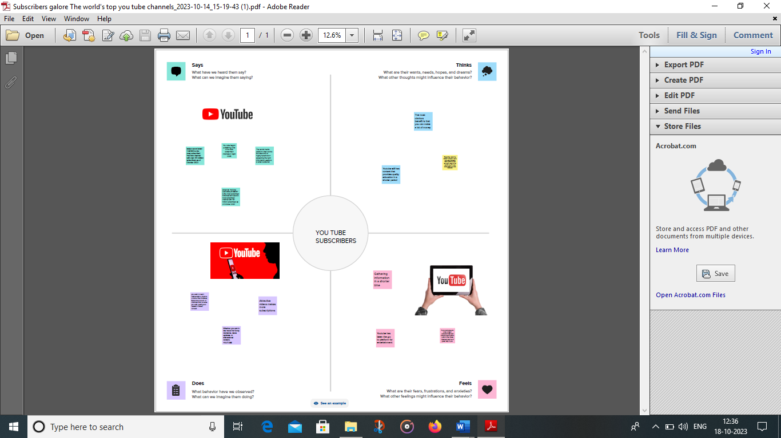

**Brainstorming Map:**

**This is just a brainstorming map, and the actual success of a YouTube channel depends on various factors, including content quality, audience engagement, and consistent efforts.**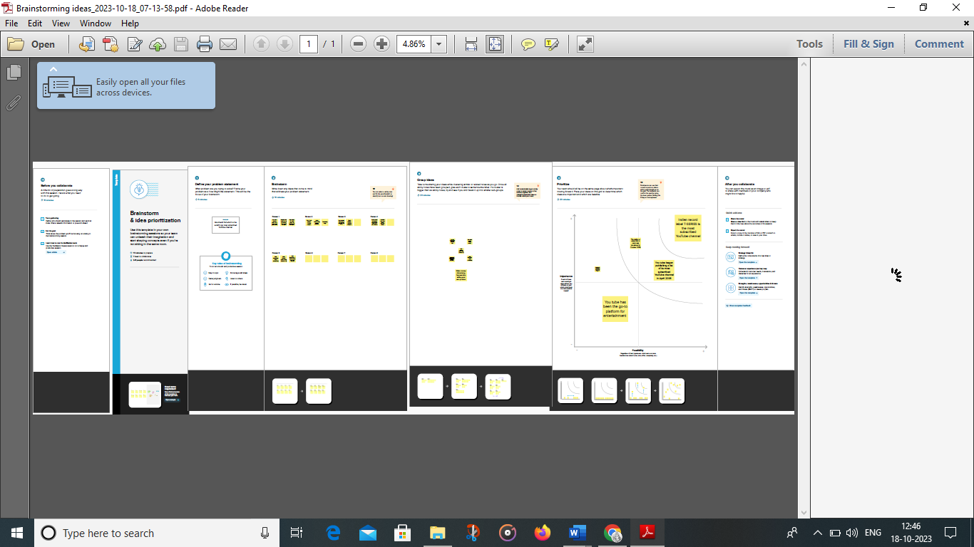

**Advantages:**

**The advantages of being the Top YouTube channel are the ability to reach a massive and diverse audience, a loyal subscriber base, advertising and sponsorship opportunities, the potential for viral content, community engagement, monetization options, influence and recognition, creative freedom, and the ability to drive trends and set industry standards.**

**Disadvantages:**

**Quality and Copyright:** The quality of videos on YouTube can vary significantly as not all videos create professionally, and some are pirated from other places and uploaded to YouTube.

* **Misinformation:**Some videos on YouTube contain misinformation or false information. Fact-checking information you find online, including those on YouTube, is essential. Taking the lead from personal vlogs can be exceptionally dangerous as that information can be precise to the people involved and might not be the best for you as an indivi